1. Agenda:
   1. Find a specific doc inside an array and work on it.
2. Two approaches
   1. Without @elemMatch
   2. With @elemMatch
3. 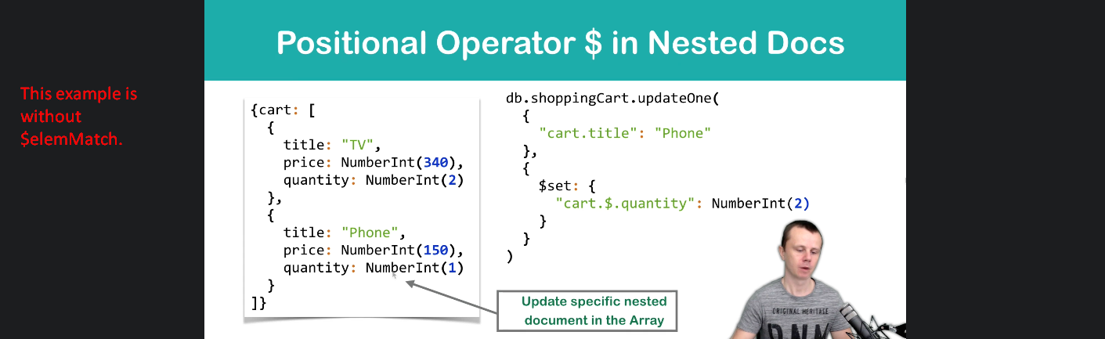
4. 